1.Given an array of strings words, return the first palindromic string in the array. If there is no such string, return an empty string "". A string is palindromic if it reads the same
forward and backward.
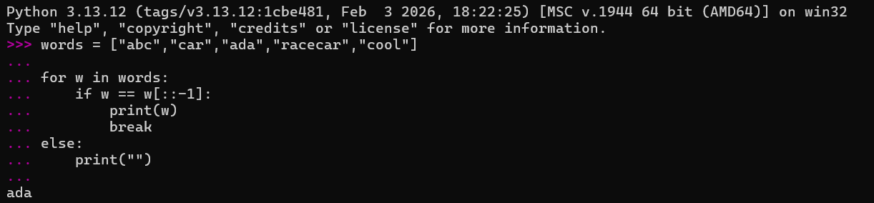
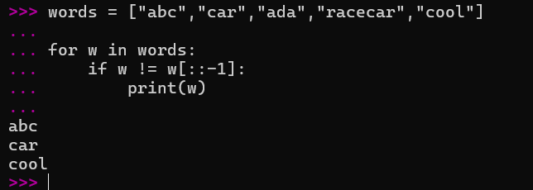

2. You are given two integer arrays nums1 and nums2 of sizes n and m, respectively.
Calculate the following values: answer1 : the number of indices i such that nums1[i]
exists in nums2. answer2 : the number of indices i such that nums2[i] exists in nums1
Return [answer1,answer2].
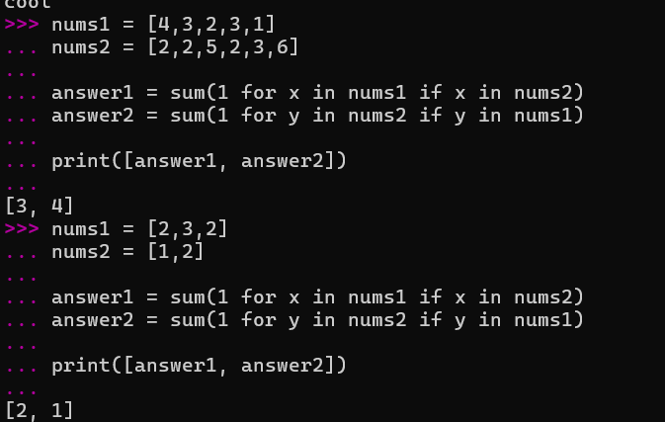

3. You are given a 0-indexed integer array nums. The distinct count of a subarray of nums is defined as: Let nums[i..j] be a subarray of nums consisting of all the indices from i to j such that 0 <= i <= j < nums.length. Then the number of distinct values in nums[i..j] is called the distinct count of nums[i..j]. Return the sum of the squares of distinct counts of all subarrays of nums. A subarray is a contiguous non-empty sequence of elements withinan array.

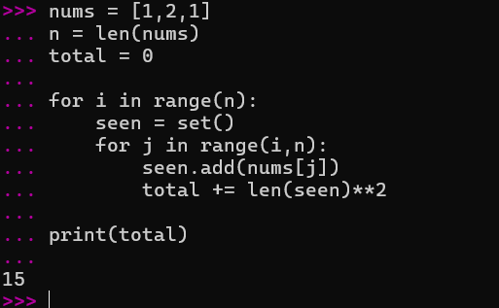

4. Given a 0-indexed integer array nums of length n and an integer k, return the number of pairs (i, j) where 0 <= i < j < n, such that nums[i] == nums[j] and (i * j) is divisible by k.
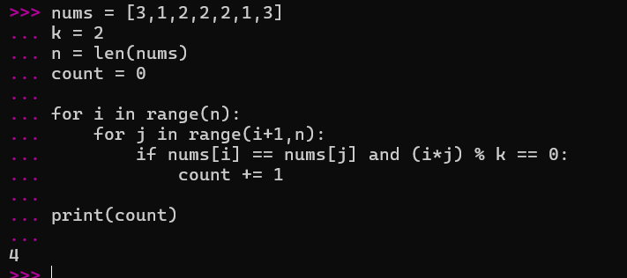

5. Write a program FOR THE BELOW TEST CASES with least time complexity
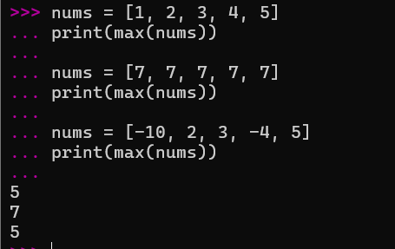
6. You have an algorithm that process a list of numbers. It firsts sorts the list using an
efficient sorting algorithm and then finds the maximum element in sorted list. Write the code for the same.
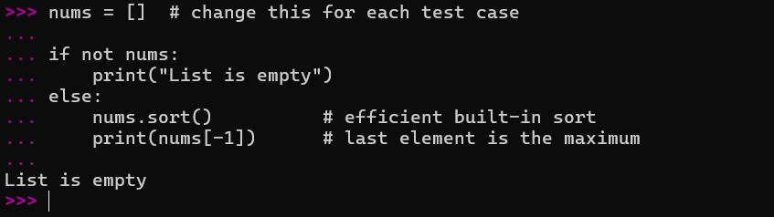

7. Write a program that takes an input list of n numbers and creates a new list containing only the unique elements from the original list. What is the space complexity of the algorithm?
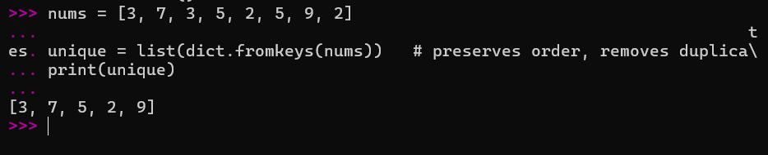

8. Sort an array of integers using the bubble sort technique. Analyze its time complexity using Big-O notation. Write the code
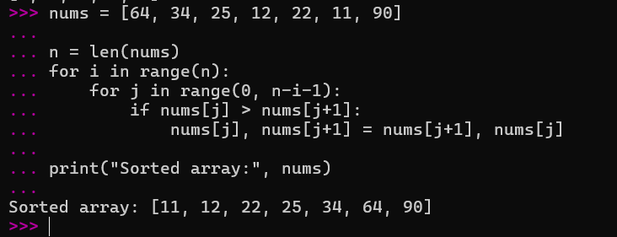
9. Checks if a given number x exists in a sorted array arr using binary search. Analyze its time complexity using Big-O notation.
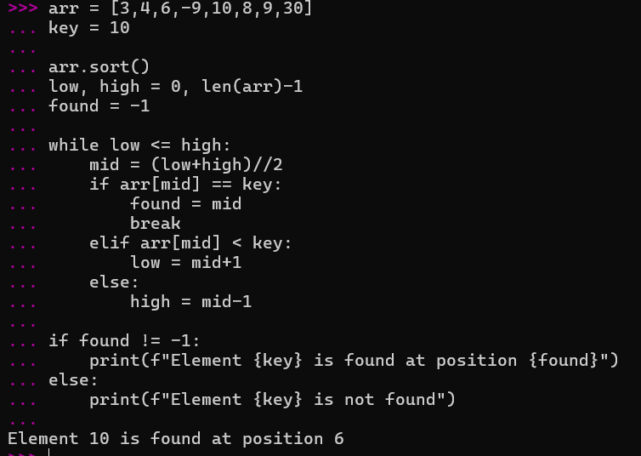

10. Given an array of integers nums, sort the array in ascending order and return it. You must solve the problem without using any built-in functions in O(nlog(n)) time
complexity and with the smallest space complexity possible.
